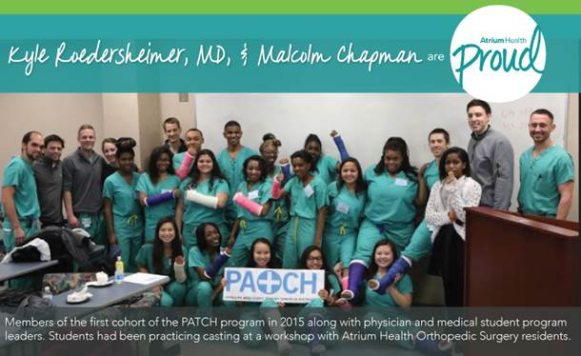

|  |  |  |  |  |  |  |  |
| --- | --- | --- | --- | --- | --- | --- | --- |
| |  |  |  |  |  |  |  | | --- | --- | --- | --- | --- | --- | --- | | |  | | --- | |  | |  | COVID-19 has put on full display the healthcare disparities in minority communities, making the mission of the Propelling Adolescents Towards Careers in Healthcare program – PATCH – more important than ever.   |  | | --- | | *This week in Atrium Health Proud, Kyle Roedersheimer, MD, & Malcolm Chapman, a medical student at UNC Chapel Hill, describe the PATCH program and its potential impact on future healthcare delivery.* |   **Dr. Roedersheimer, how does the PATCH program work?**  **KR:** It is a collaboration between Atrium Health, the UNC School of Medicine and Charlotte-Mecklenburg Schools. We recruit primarily by going to local high schools and engaging with freshmen and their teachers, but also on social media and our [website](http://s.bl-1.com/h/cX9llMHy?url=https://www.thepatchprogram.org/). Starting in the latter part of their sophomore year, PATCH scholars take part in an eight-week curriculum held every Saturday at Atrium Health Carolinas Medical Center. The students shadow healthcare professionals, take part in interactive workshops, and complete a public health research project. Their junior year provides college-placement test prep, and the senior curriculum includes sessions around college readiness. So far, 123 participants have developed a strong understanding about healthcare careers and pathways to higher education.  **Why did you create the PATCH program?**  **KR:** Before medical school, I spent three years teaching science at Garinger High School, one of Charlotte's schools where the majority of students are considered economically disadvantaged. I was profoundly impacted by the many passionate and intelligent students who wanted to pursue a career in medicine, but for whom navigating many of the requirements was challenging. Once in med school, I witnessed a lack of diversity in healthcare education and the workforce. Two fellow UNC medical students and I started the PATCH program in 2014 to help Charlotte students like those at Garinger gain exposure to careers in healthcare.  **Malcolm, why did you want to be a PATCH mentor?**  **MC:** In my youth, I was fortunate to have a wealth of mentors. What I learned from them helped me get into college and propelled me to where I am today, pursuing my medical degree and Master of Business Administration. In 2017, I learned about PATCH from representatives of the UNC School of Medicine-Charlotte Campus and decided to spend my third year there. In December 2018, I applied for and secured a spot as a co-leader of the 2020 PATCH program.  **What has been your experience?**  **MC:** It’s been great! My personal reward is to watch my mentees get accepted to college and begin careers – to see closed doors open for students who often are never told about the doors in the first place.  **What’s the future of PATCH?**  **KR:** We plan to increase the number of PATCH scholars, integrate more lasting mentorship throughout college in preparation for professional school, and add rigorous coursework and internship experiences. I am #AtriumHealthProud that PATCH is a viable pipeline program for minorities and economically disadvantaged high school students.  **Kyle M. Roedersheimer, MD**  Staff Physician  Atrium Health Carolinas Medical Center  **Malcolm B. Chapman**  MBA ’22, UNC Kenan-Flagler Business School  MD ’22, UNC School of Medicine  ***If you know a student who would be interested in the PATCH program, visit the*** [***Teammate site***](http://s.bl-1.com/h/cX9llSh0?url=https://teammates.atriumhealth.org/careers/career-development-center/patch-program) ***to learn more****..*  [***https://teammates.atriumhealth.org/careers/career-development-center/patch-program***](https://teammates.atriumhealth.org/careers/career-development-center/patch-program)  ***Applications will be accepted November 6, 2020 – December 1, 2020****.* | |  |  | | |